10 4 11 2 6 9 5 12 14 20

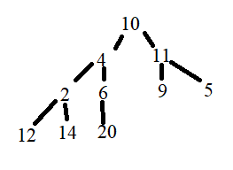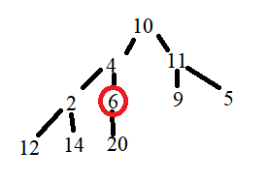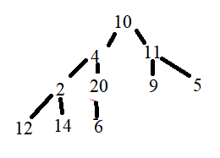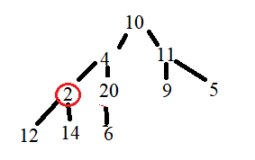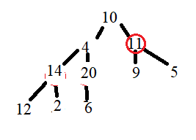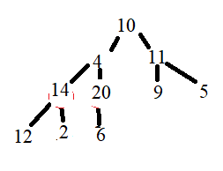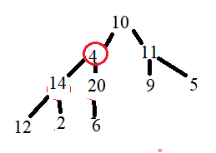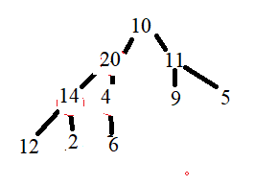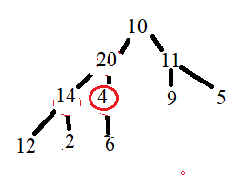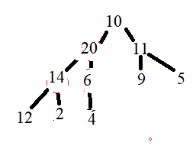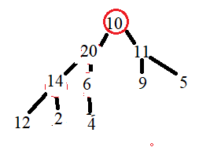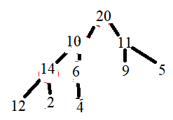

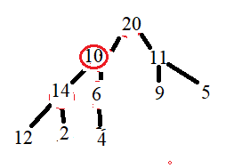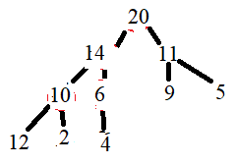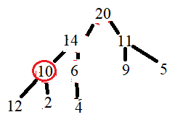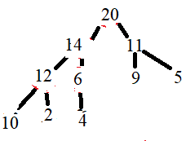

* Insert S1 = 6, 17, 5, 4, 9, 11, 3, 16, 20, 7:

+ Insert 6:

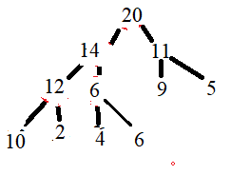 6 <= 6 so keep their positions.

+ Insert 17:

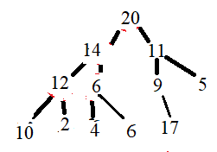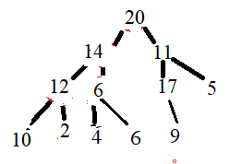17 > 9 -> swap their positions. (or 17 swim up)

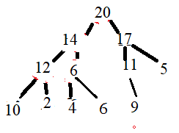17 > 11 -> swap their positions (or 17 swim up). 17 < 20 -> keep their positions.

+ Insert 5:

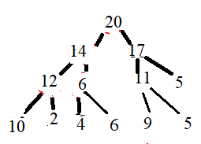5 < 11 -> keep their positions.

+ Insert 4:

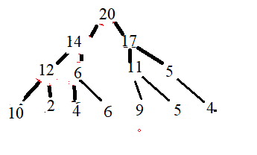4 < 5 -> keep their positions.

+ Insert 9:

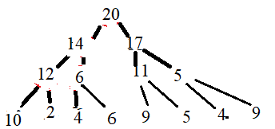 9 > 5 -> swap their positions.

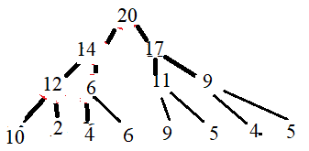9 < 17 -> keep their positions.

+ Insert 11:

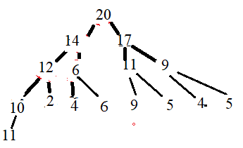11 > 10 -> swap their positions.

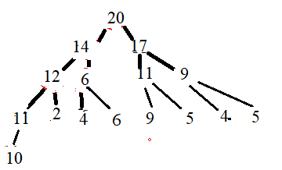11 < 12 -> keep their positions.

Do the same with other elements.

* Find & delete max element in heap tree:

Max element is root element (20).

Swap root with last element in tree (10).

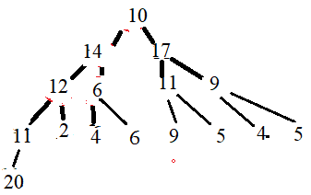 then delete 20 (delete easily cause 20 is a leaf now).

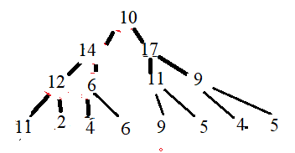17 is child of 10 and greater than 10 (and other child of 10 (14) ) -> swap 10 and 17 position.

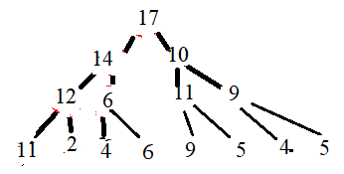Do the heapify with sub tree with 10 is root.

9 < 10 < 11 -> swap 10 and 11.

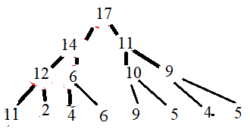Do the heapify with sub tree with 10 is root.

5 < 9 < 10 -> keep their positions, NO more heapify.